**AIR QUALITY MONITORING SYSTEM**

**[IOT Devices]**

**INTRODUCTION :**

**The quality of the air we breathe profoundly impacts our health, environment, and overall well-being. With the increasing concern for air pollution and its adverse effects on public health, the need for accurate and real-time air quality monitoring has become paramount. To address this imperative, we embark on a journey to design an advanced Air Quality Monitoring System leveraging the power of Internet of Things (IoT) technology. This system aims to monitor critical air quality parameters in real-time, share valuable data with the public and relevant authorities, raise public awareness, and understand the health implications of varying air quality levels.**

**Our approach involves careful selection and integration of cutting-edge sensors into IoT devices, strategically positioned to capture comprehensive air quality data. Through a robust data processing and analysis pipeline, we seek to convert raw sensor data into actionable insights, paving the way for a user-friendly web-based platform.**

**In this endeavor, we explore the intricate interplay between hardware, software, data analytics, and user engagement to craft a comprehensive Air Quality Monitoring System that not only addresses the exigency of accurate data but also fosters a sense of shared responsibility towards a sustainable and pollution-free future.**

**Project Objectives:**

1. **Real-Time Air Quality Monitoring: Develop and implement IoT devices equipped with advanced sensors to continuously monitor and report real-time air quality parameters, including particulate matter (PM2.5, PM10), carbon monoxide (CO), nitrogen dioxide (NO2), sulfur dioxide (SO2), ozone (O3), and other relevant pollutants.**
2. **Data Sharing and Accessibility: Establish a secure and user-friendly web-based platform for sharing the collected air quality data with the public, researchers, policymakers, and other stakeholders. Ensure accessibility to this platform to encourage transparency, data-driven decision-making, and public awareness regarding air quality issues.**
3. **Public Awareness and Education: Utilize the collected air quality data to raise public awareness about the health risks associated with varying air quality levels. Develop educational content to inform the public about the impacts of air pollution and the importance of proactive measures to mitigate its effects.**
4. **Health Impact Assessment: Analyze the collected air quality data to assess the direct and indirect health impacts on the community. Collaborate with healthcare professionals and researchers to understand correlations between air quality levels and public health, facilitating evidence-based healthcare interventions.**
5. **Alert System and Threshold Monitoring: Implement an automated alert system within the web platform to notify users and relevant authorities when air quality levels exceed predefined thresholds. These alerts will enable timely responses to mitigate potential health risks and environmental damages.**

**STRUCTURE :**

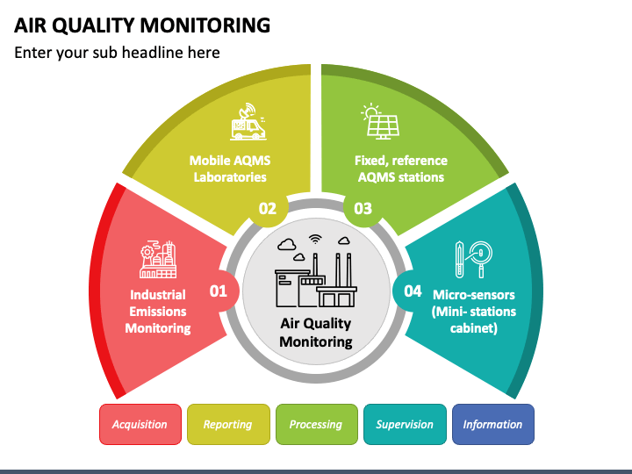

**PROCEDURE :**

1. **Sensor Selection and IoT Device Design: a. Sensor Types:**
   * **Choose appropriate sensors for measuring key air quality parameters such as particulate matter (PM2.5, PM10), carbon monoxide (CO), nitrogen dioxide (NO2), sulfur dioxide (SO2), ozone (O3), and other relevant pollutants. b. IoT Device Design:**
   * **Design IoT devices that integrate the selected sensors, ensuring power efficiency, data accuracy, and reliability.**
   * **Include necessary components such as microcontrollers, communication modules (e.g., Wi-Fi, GSM), power management systems, and casing to protect the device from environmental factors.**
2. **Data Acquisition and Transmission:**
   * **Configure the IoT devices to collect air quality data at regular intervals.**
   * **Establish communication protocols (e.g., MQTT, HTTP) for transmitting the collected data securely and efficiently to a centralized server or cloud platform.**
3. **Data Processing and Analysis:**
   * **Develop algorithms and models to process the raw data and derive meaningful insights.**
   * **Integrate machine learning or AI techniques to identify patterns, trends, and anomalies in the air quality data.**
   * **Calculate air quality indices based on established standards and guidelines.**
4. **Data Storage:**
   * **Implement a reliable and scalable database to store the processed air quality data.**
   * **Ensure proper data management practices, including data cleaning, aggregation, and archival.**
5. **Web-Based Data Visualization Platform:**
   * **Design a user-friendly web interface accessible to the public and relevant stakeholders.**
   * **Create visualizations such as graphs, charts, and maps to present real-time and historical air quality data in an understandable format.**
   * **Enable users to customize views, set alerts, and access detailed information about air quality parameters.**
6. **Alerts and Notifications:**
   * **Implement an alerting system to notify users, local authorities, or stakeholders when air quality levels exceed predefined thresholds.**
   * **Provide notifications through email, SMS, or push notifications on the web interface or mobile applications.**
7. **User Engagement and Public Awareness:**
   * **Integrate educational content and information about the health impacts of various pollutants.**
   * **Engage the community by encouraging users to contribute and share their observations, feedback, or suggestions to improve air quality.**
8. **Security and Privacy:**
   * **Ensure data security and privacy by implementing encryption, access controls, and compliance with relevant regulations (e.g., GDPR, HIPAA).**
   * **Regularly update and patch the system to address potential vulnerabilities.**
9. **Scalability and Maintenance:**
   * **Design the system to be easily scalable as the monitoring network expands.**
   * **Plan for regular maintenance, updates, and hardware replacements to ensure long-term functionality and reliability.**

**By carefully considering these aspects and employing a multidisciplinary approach involving hardware, software, data processing, and user engagement, an effective Air Quality Monitoring System can be designed to improve public health and environmental quality.**

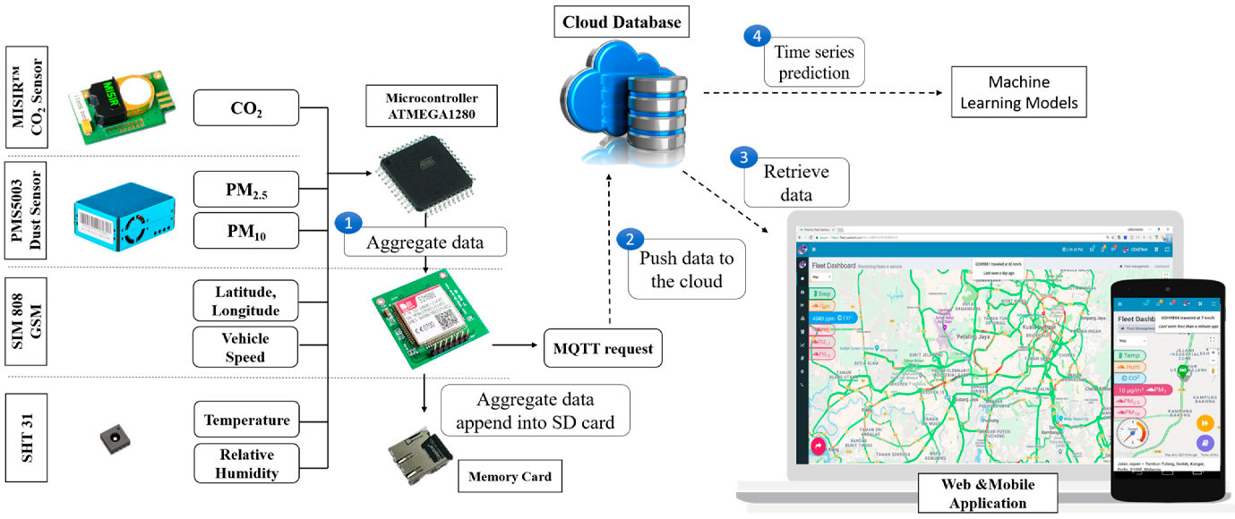

**Design**

**CONCLUSION :**

**In the pursuit of a sustainable and healthier future, the development and implementation of an advanced Air Quality Monitoring System represent a significant stride forward. This project has focused on harnessing the potential of Internet of Things (IoT) technology to address the critical concern of air pollution and its far-reaching impacts on public health and the environment.**

**The realization of real-time air quality monitoring through strategically deployed IoT devices has been a central accomplishment. These devices, equipped with high-precision sensors, continually gather data on various air quality parameters. This data is then processed and presented in a user-friendly web-based platform, empowering the public and stakeholders with valuable insights into air quality trends, patterns, and health implications.**